**Project report template**

1. INTRODUCTION:-

1.1 Overview

Retail Management deals with selling of goods and services to consumers. It involves a direct interaction with the customer and coordinating business activities from designing of a product to its delivery and post-delivery service. Those who are specialists in retail management are generally known as Retail Managers. A Retail Manager is expected to address consumers’ problems, monitor retail orders, handle merchandising, manage HR and also supervise the stocks/inventory and supply chain management.

1.2 Purpose

Retail management optimizes internal processes such as inventory management, offline and online storefronts, warehouse operations, payment and accounting, and human resources. Retail management improves overall company cohesion. Retail store management improves customer experience and boosts customer satisfaction.

A retail management CRM ( Customer Relations Management) software is a tool to automate the customer interactions data in the retails store. This software stores information about the customer purchase history and the coupon utilisation. This could help us in predicting the buying tendency and the requirement of customer in near future and send personalised information about particular product offers to customer.

2. PROBLEM DEFINITION & DESIGN THINKING :

2.1 Empathy Map

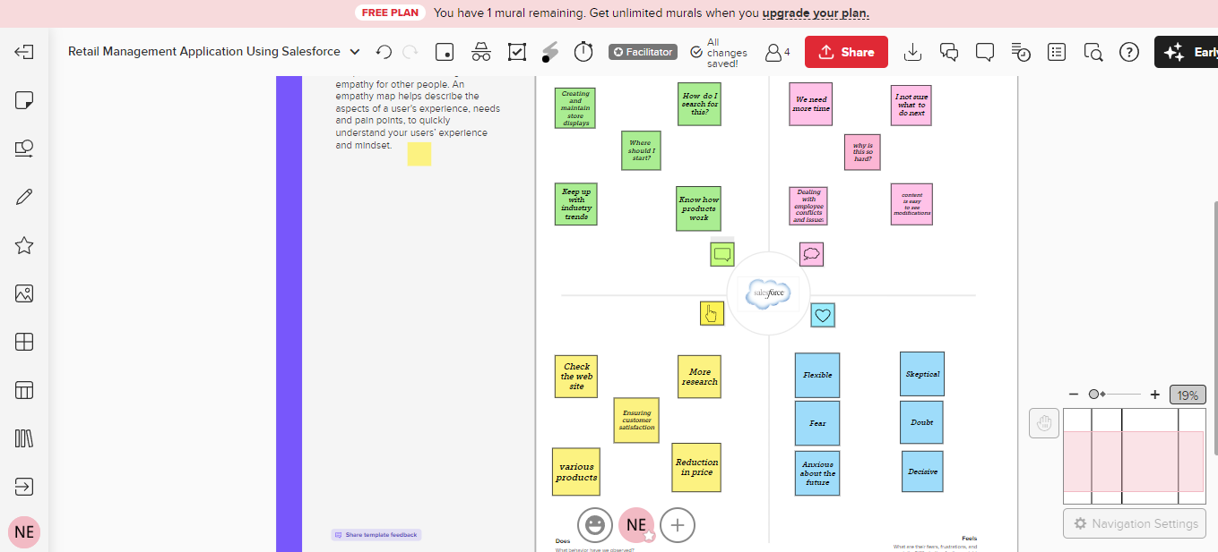

2.2 Ideation & Brainstorming Map

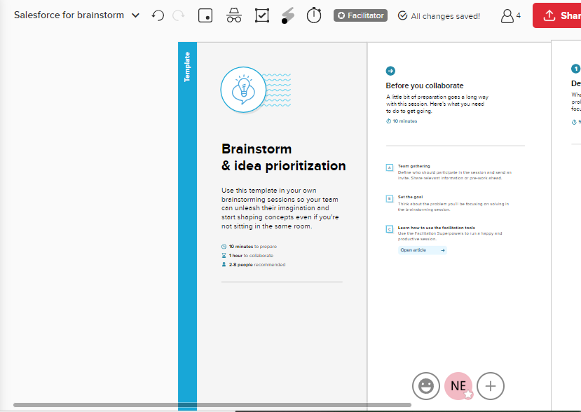

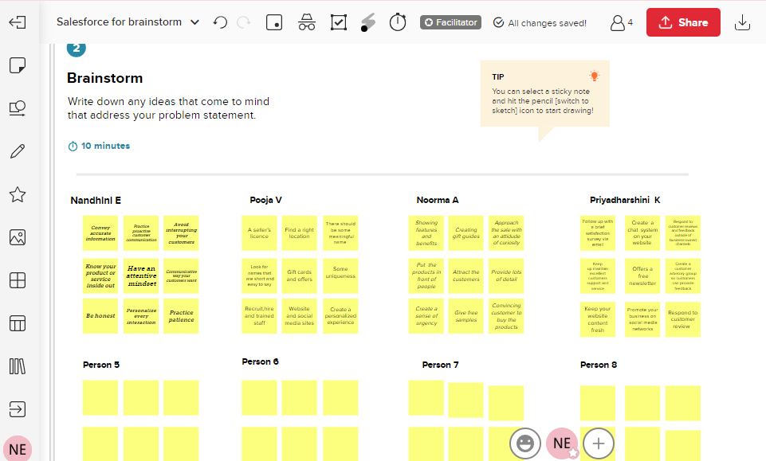

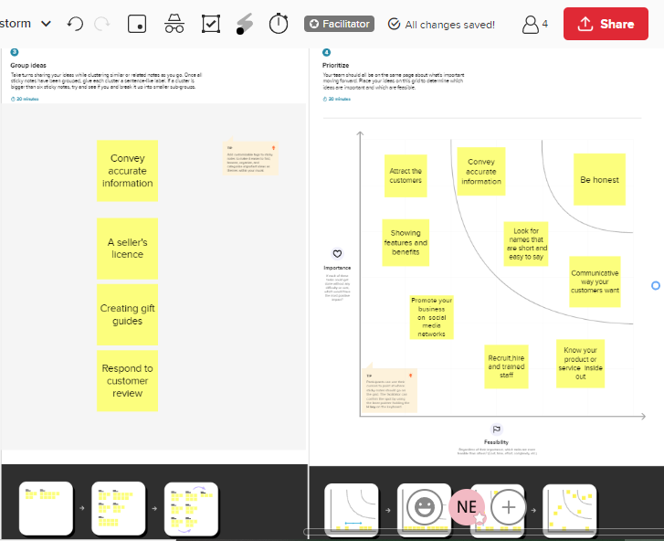

3. Result:

3.1 Data Model

|  |  |
| --- | --- |
| Object Name | Fields in the object |
| Object 1 | |  |  | | --- | --- | | Field label | Data type | | Dispatch/tracking | Text | |
| Object 2 | |  |  | | --- | --- | | Field label | Data type | | Sales Order | Master-Detail | |

3.2 Activity & Screenshot

Create Salesforce Org-creating Developer account

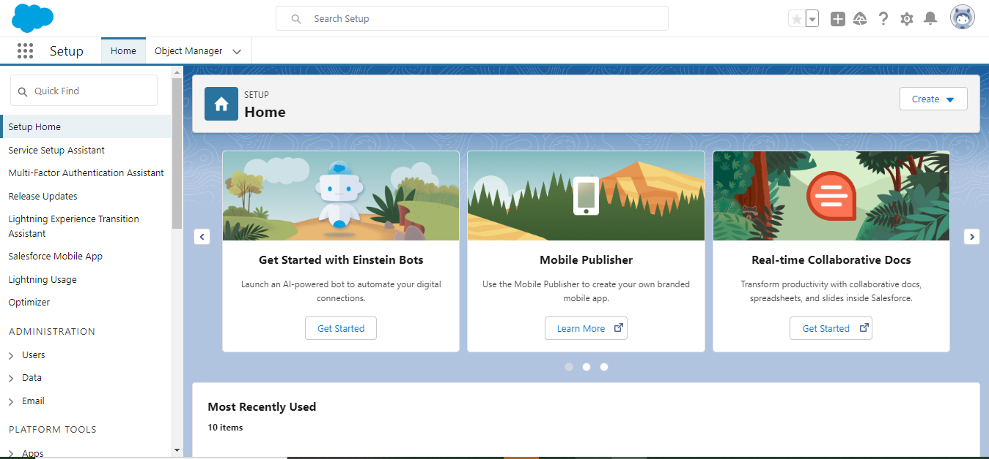

Object Manager:

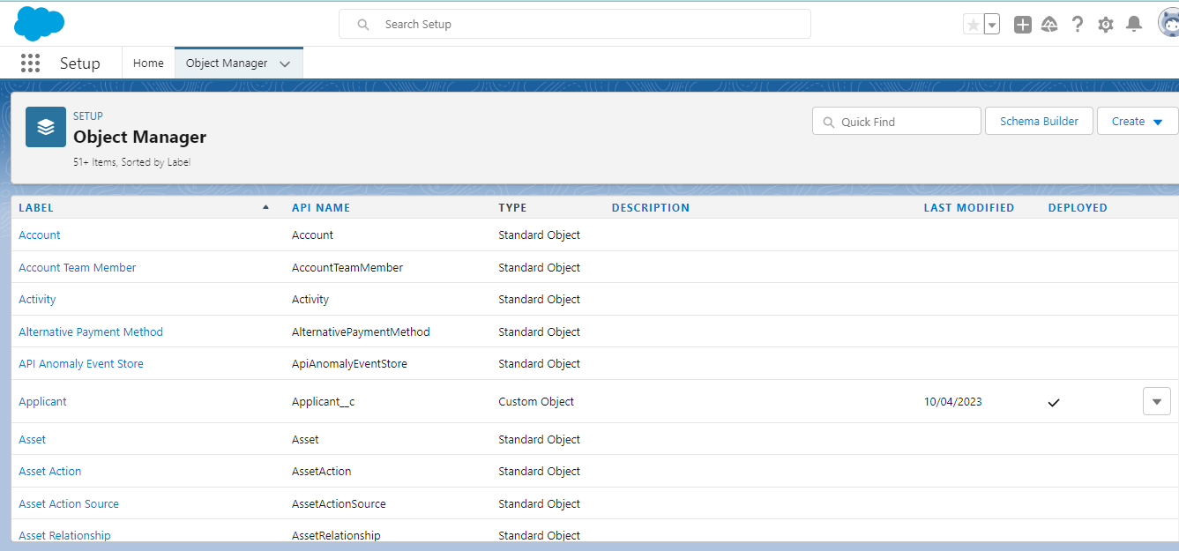

* Dispatch /tracking object

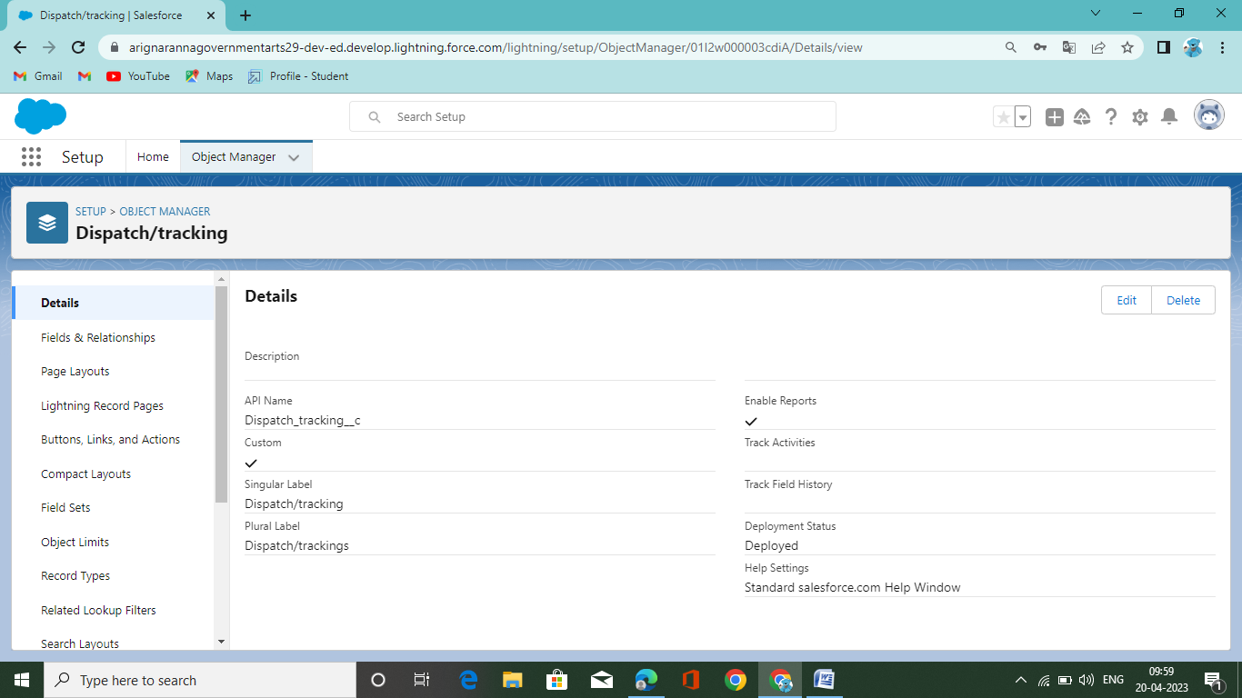

Creation of Fields &Relationship

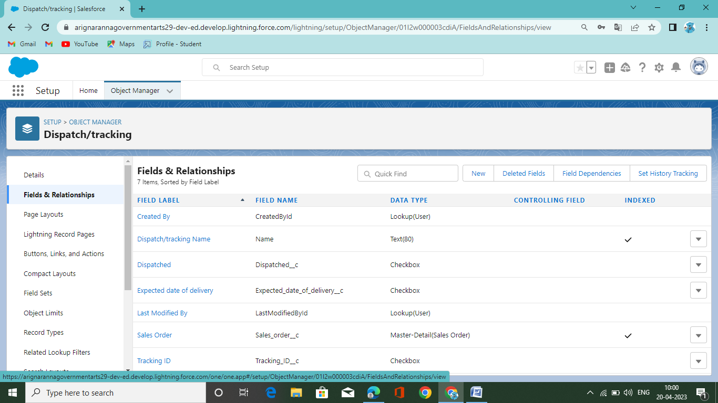

Creation of page layouts

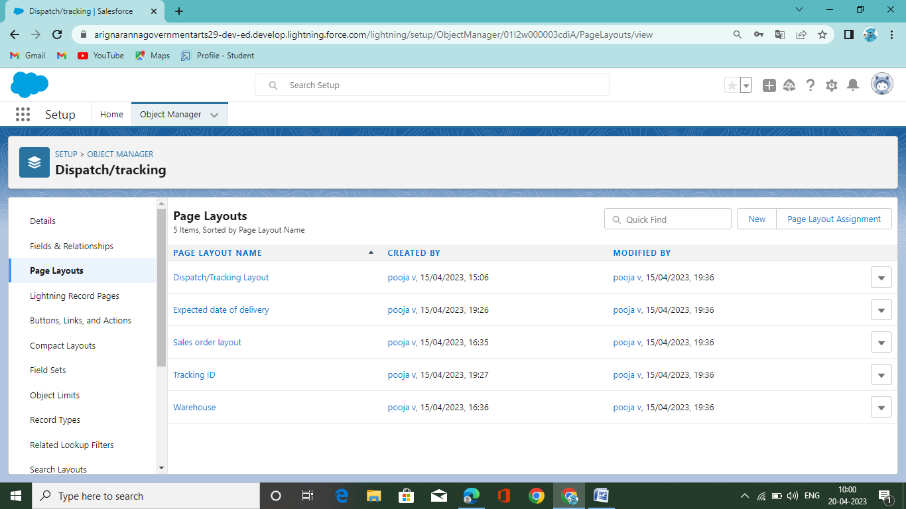

Creation of Record Type

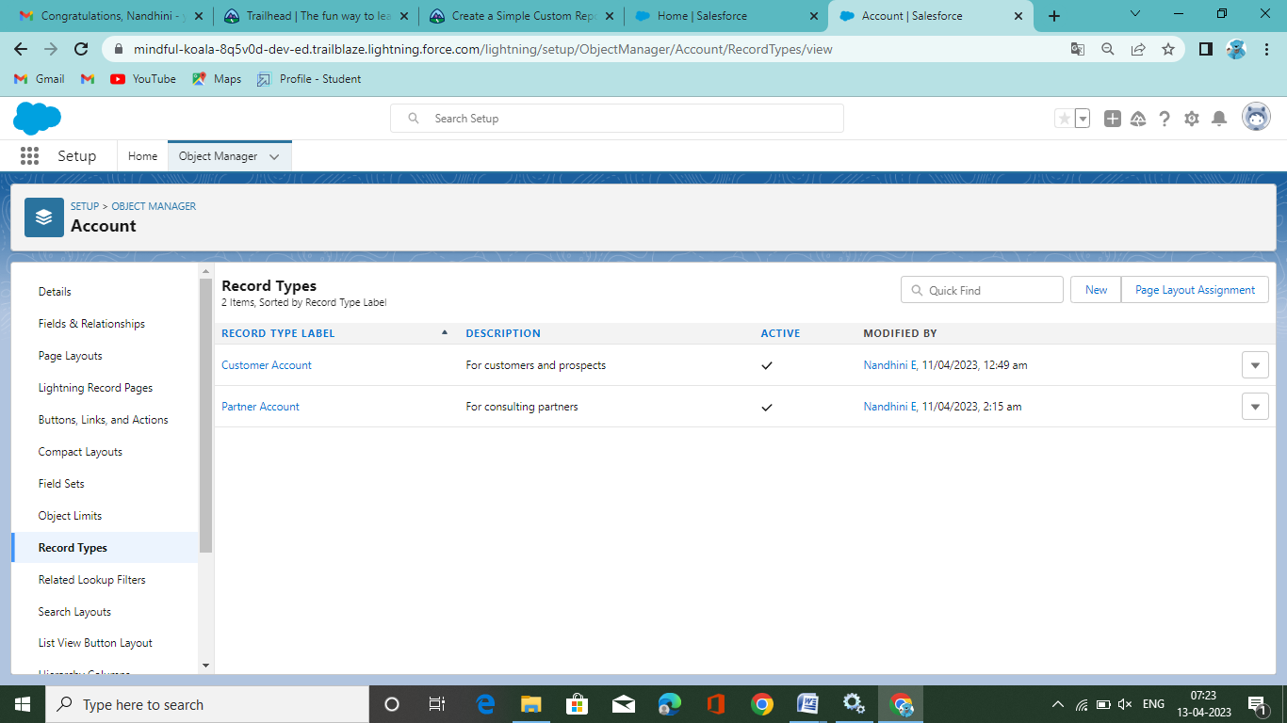

Creation of Validation Rules

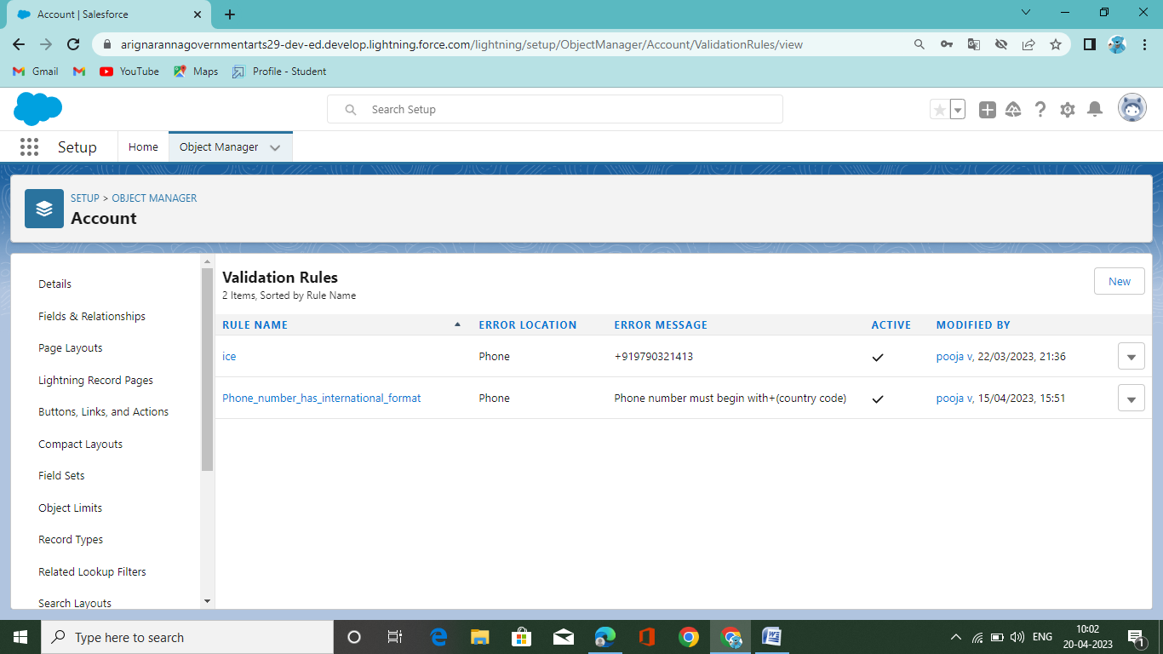

Creation of Sales App

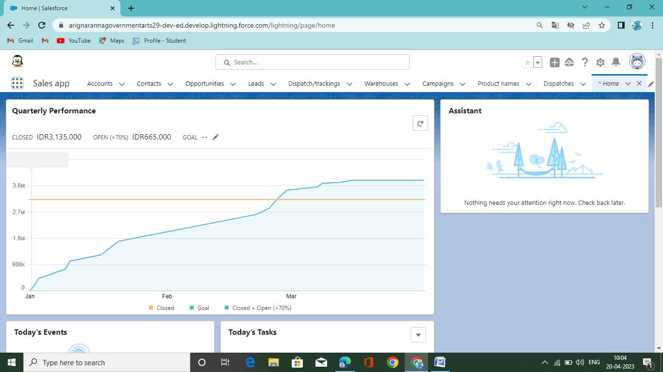

Creation of Accounts in Sales App

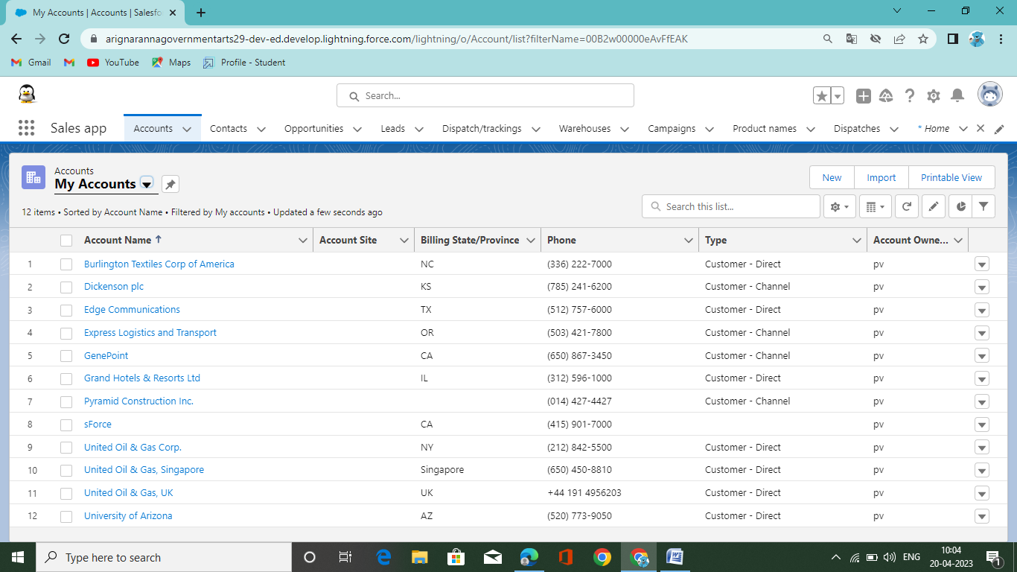

Creation of Contacts in Sales App

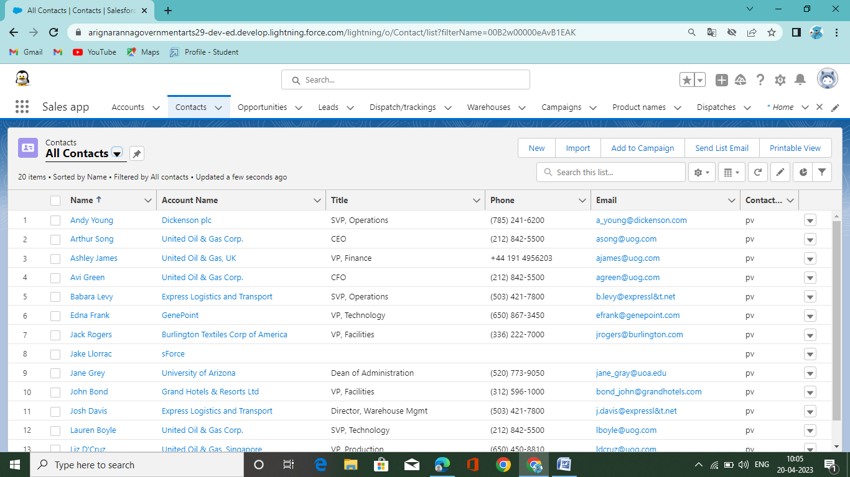

Creation of Dashboards in Sales App

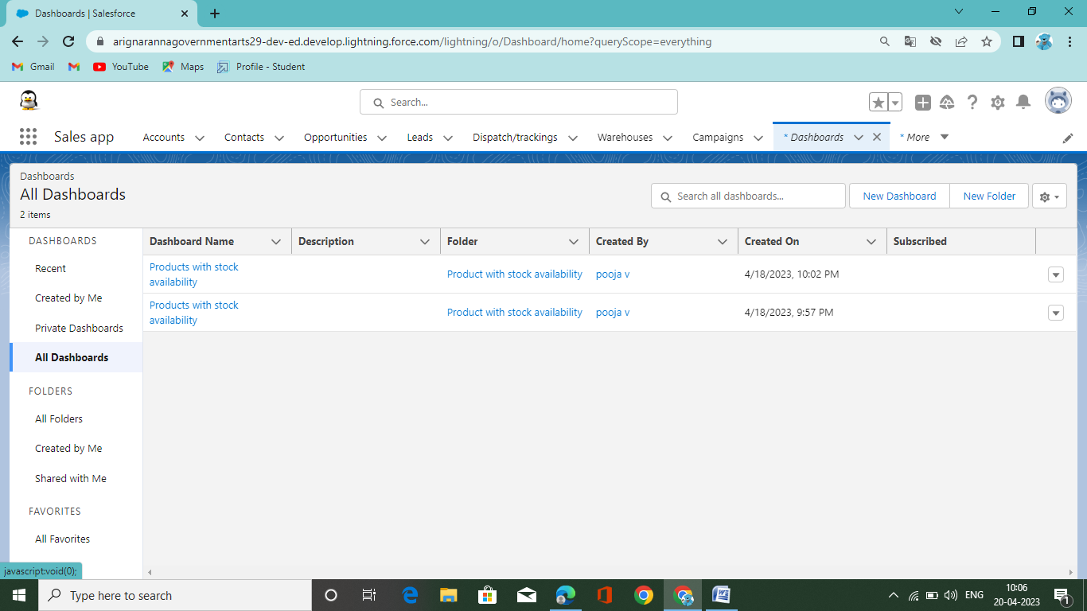

Creation of Reports in Sales

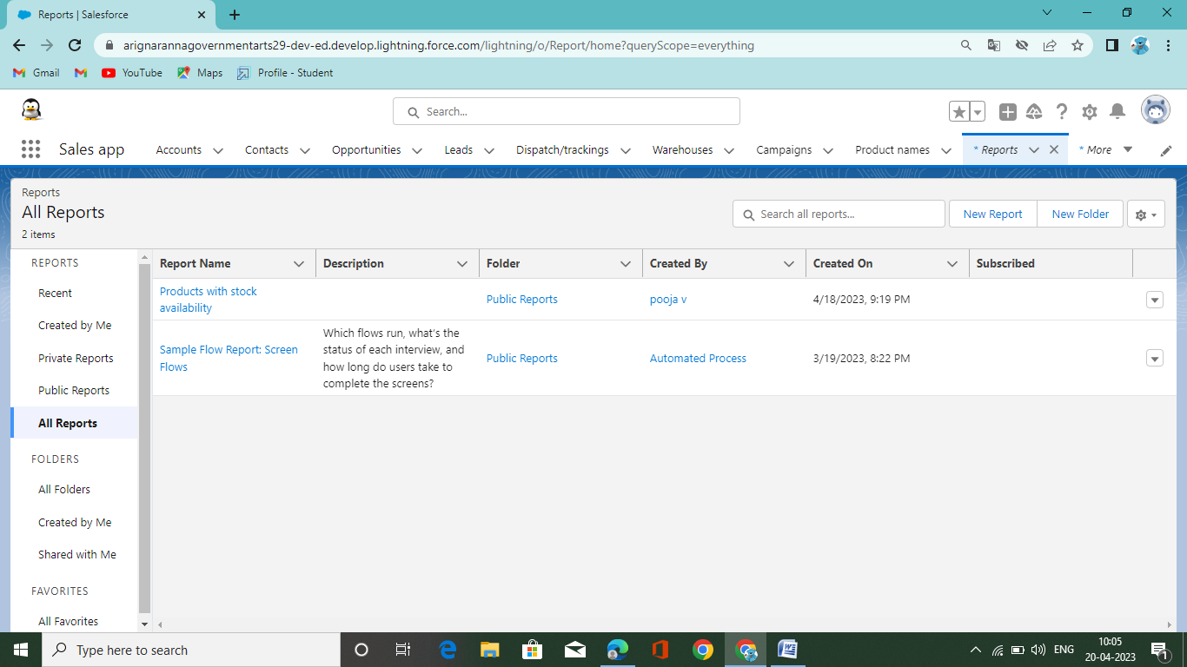

Profile

Creation on Profile

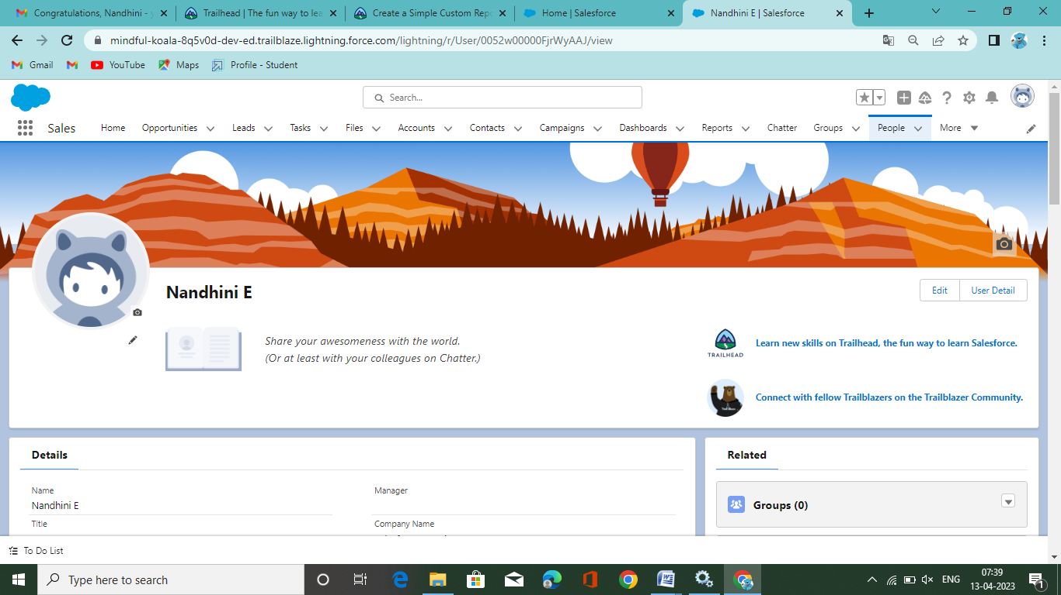

Creation of Users

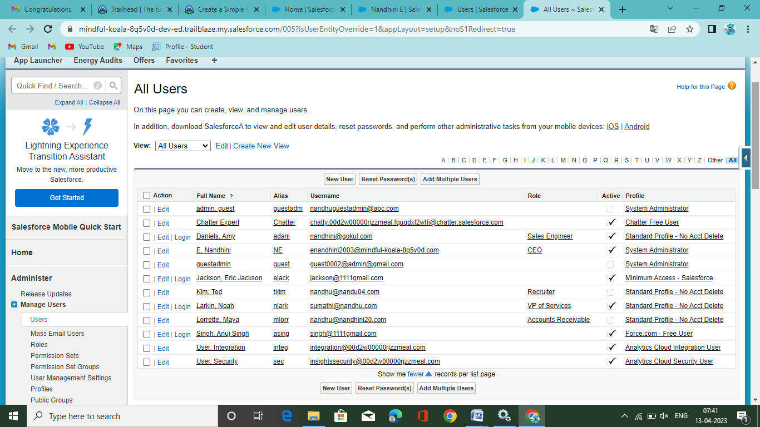

Creation of Permission Sets

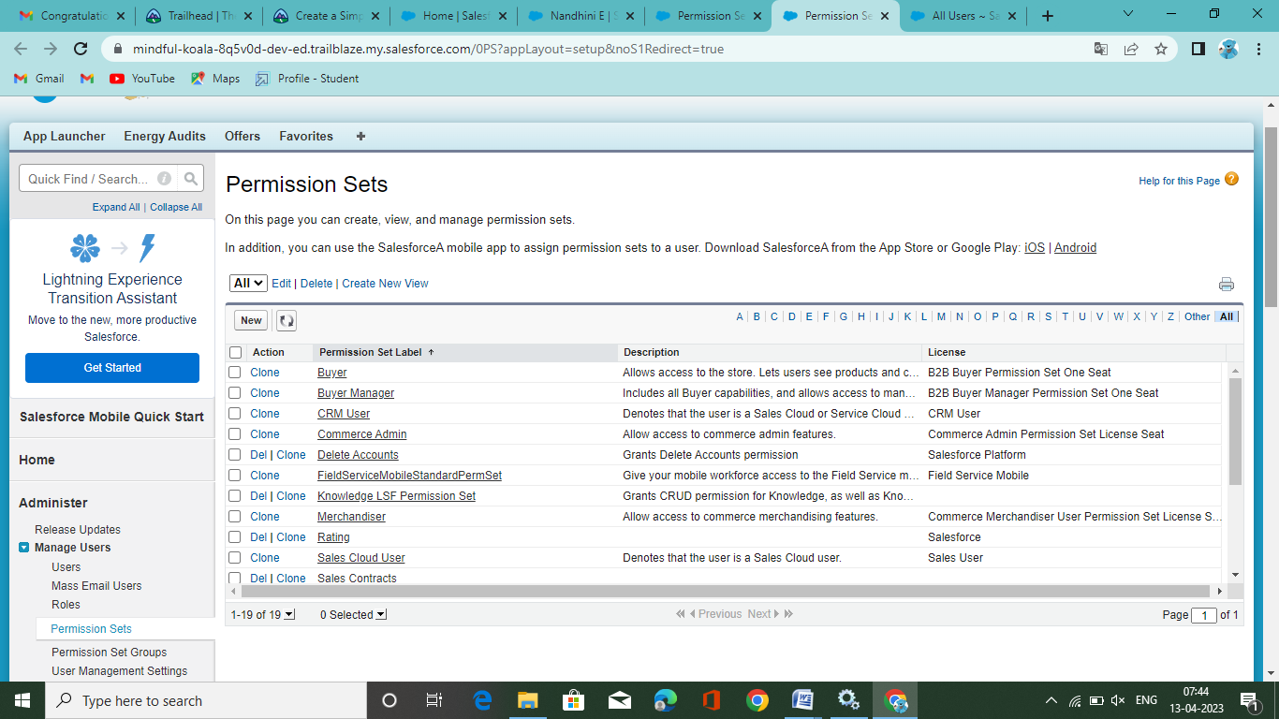

Creation of permission Sets Group

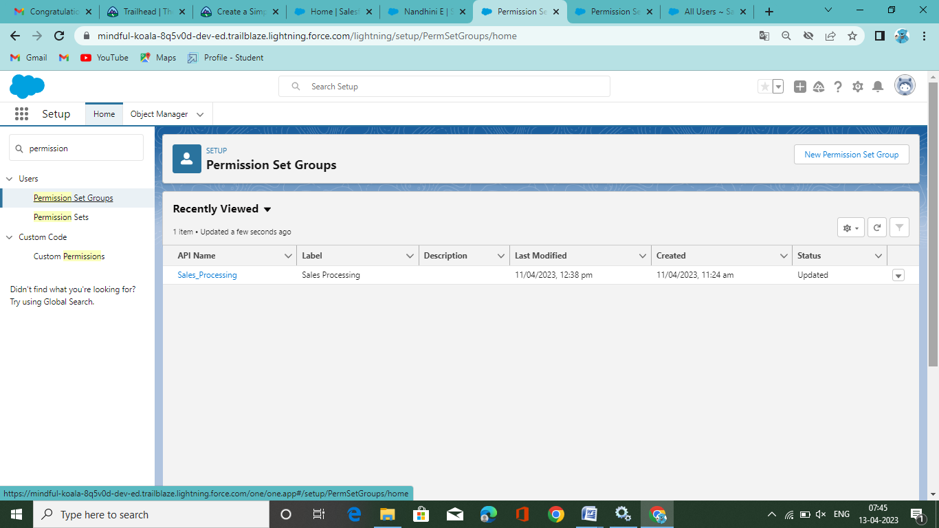

Creation of Company information

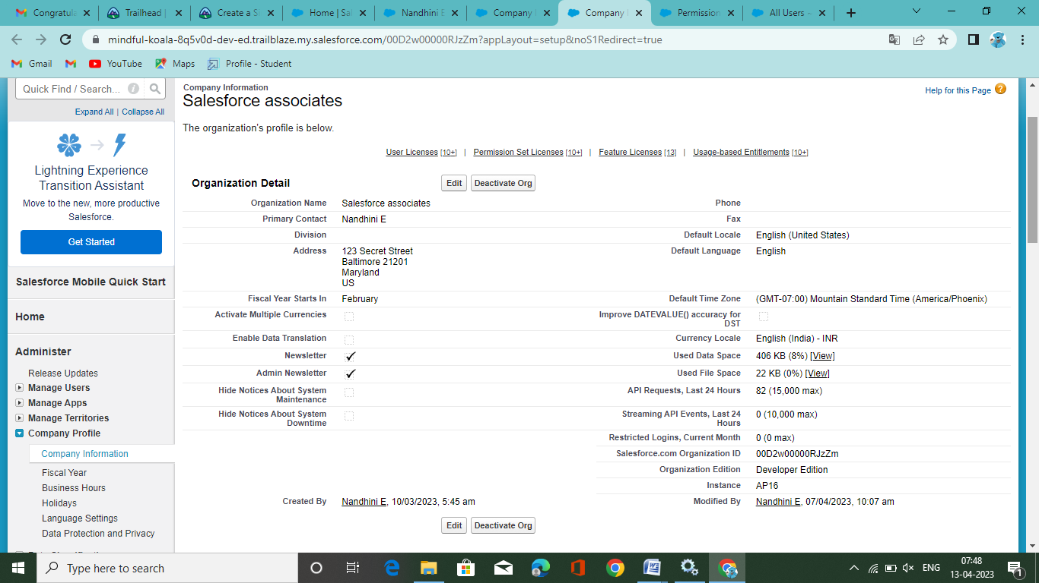

4. Trailhead Profile public URL:

Team Lead- <https://trailblazer.me/id/poojv9>

Team member 1- <https://trailblazer.me/id/nandu186>

Team member 2- [https://trailblazer.me/id/noorma](%20https://trailblazer.me/id/noorma)

Team member 3- <https://trailblazer.me/id/pdharshinik>

5. ADVANTAGES & DISADVANTAGES:

* **Less Capital Requirement**

It does not require huge investment to start retail business. Retailers buy goods from wholesalers in small large space to store goods. So, retailing can be commenced with little investment.

* **More Profit Margin**

There is fixed margin of profit for wholesalers. Generally they earn 3% to 8% profit on sale. But there is no fixed margin for retailers, shopkeepers may fix profit margin up to 20% in some cases.

* **Credit Facility**

Another benefit of retailers is that they get credit facility from wholesalers or dealers. But they sell products on cash which helps to maintain adequate liquidity in the business.

* **Better Customer Relation**

Retailing is directly linked with the customers. Retailers can understand the interests, preferences and buying behaviour of customers. It helps to build better customer relation and loyalty.

* **No Liability**

In case of faulty or defective products, the do not need to bear to loss.

Disadvantages of Retailers

* **High Marketing Cost**

Retailers should make investment decoration of shop and display of goods to attract more customers. So, it requires more marketing or advertising cost then wholesalers.

* **Very High Competition**

Another disadvantages of retailing is that there is tough competition in the market becauseseveral retailers sell similar types of products. So, it is difficult to remain in the competitive environment.

* **No Economics of Buying**

Retailers buy small volume of products form wholesalers, So, they miss the opportunity to enjoy he benefit of economics of buying.

6. APPLICATION

Retail management software is technology that helps business owners drive more sales with applications that include point of sale features, inventory management, retail customer relationship management and more. These solutions often include hardware for payment terminals and can support mobile devices.

7. CONCLUSION

In this course we have explored the meaning of the terms retailing, marketing and marketing communications. We have also considered the importance of the marketing mix and identified the different communication tools that a retailer might use to interact and communicate with their target customers. You have been introduced to a few theoretical concepts and ideas, which have been illustrated using real world examples and cases in retailing.

You have been introduced to some of the key areas of marketing communications the message, the media and the communication tools. You have considered the basics of the communication model that underpins the development of marketing communication messages. You have also explored what it takes to develop a communication message, how to use communications to build a brand and the characteristics of the different media that might carry marketing communications. In addition, you have identified a range of communication tools which make up the marketing communication mix.

The course has also aimed to introduce the importance of marketing and communication from a retail perspective.

8. FUTURE SCOPE

* Functions of Retailers

Retailer provides the goods that customer need, in a desired form, at a required time and place.

* A retailer does not sell raw material. He sells finished goods or services in the form that customer wants.
* A retailers buys a wide range of products form different wholesalers and offers the best products under one roof. Thus, the retailer performs the functions of both buying and selling.
* A retailer keeps the products or services within easy reach of the customer by making them available at appropriate location.
* Scope
* Store management
* Category management
* Customer Relationship Management
* Vendor Management
* Inventory Management
* Supply Chain Management